Please ensure that all patients referred using this proforma have radiological evidence of metastatic disease and NO primary origin of this cancer.  ☐Metastases found on Liver USS ( If there is a solitary lesion, please refer using the Upper GI two week wait referral form):  Scan date and location:  ☐CT scan:  Scan date & location:  ☐MRI:  Scan date & location:  ☐Bone scan (Suspicious bone metastases with no obvious primary clinically and a normal PSA, and negative myeloma screen):  Scan date & location:  ☐Other scan: |  |  | 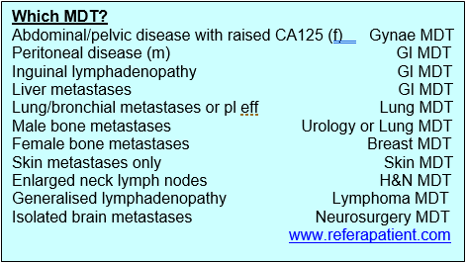  For information, please refer below to site specific MDT as indicated. If a patient has non-specific symptoms but suspicious for malignancy, please refer on the 2WW NSS pathway
Previous Diagnosis of Cancer
Yes ☐ No ☒
Specify site and month/year of diagnosis:
If yes, has this site been investigated for recurrence?
Yes ☐ No ☐
Please attach as much information as possible about diagnosis, hospital involved and treatment received
Smoking Status: |  |  | WHO Performance Status:  ☐0 Fully Active  ☐1 Able to carry out light work  ☐2 Up & about greater than 50% of waking time  ☐3 Confined to bed/chair for greater than 50%  ☐4 Confined to bed/chair 100%
Alcohol status:
BMI

Clinical Details:

Cancer of Unknown Primary Two Week Wait Referral Form
Referrer Details | Patient Details
Name: | Name: |  |  |  | DOB:
Address: | Address: |  |  |  | Gender:
 |  |  |  |  | Hospital No.:
 |  |  |  |  | NHS No.:
Tel No: | Tel No. (1): |  |  |  | Please check telephone numbers
 | Tel No. (2):
Email: | Carer requirements (has dementia or learning difficulties)? |  |  |  | Capacity concerns?
Decision to Refer Date: | Translator Required: Yes☐No ☐Language: |  |  |  | Mobility:
 | ☐ | Military Service Person | ☐ | Military Veteran | ☐ | Member of Military Family

Tumour markers (if available):

☐CA125: ☐CEA: ☐AFP: ☐CA15-3: ☐CA19.9:
Please confirm that the patient has been made aware that this is a suspected cancer referral: Yes☐ No ☐

Please confirm that the patient has received the two week wait referral leaflet: Yes☐ No☐

Please provide an explanation if the above information has not been given:

If your patient is found to have cancer, do you have any information which might be useful for secondary care regarding their likely reaction to the diagnosis (e.g. a history of depression or anxiety, or a recent bereavement from cancer might be relevant) or their physical, psychological or emotional readiness for further investigation and treatment?

Date(s) that patient is unable to attend within the next two weeks

If patient is not available for the next 2 weeks, and aware of nature of referral, consider seeing patient again to reassess symptoms and refer when able and willing to accept an appointment.

Please attach additional clinical issues list from your practice system
Details to include:

Past medical and surgical history:

Current medication:

Allergies:

Relevant family history:

Blood Results (Last 2m):
Hb | WBC | Neutrophil |  | Platelets
Sodium | Potassium | Creatinine |  | Urea
ALT | AST | Bilirubin | Albumin | ALP
CRP
INR
Ca | Adjusted Ca | Phosphate |  | Magnesium
TFT | Glucose | Other tests
Trust Specific Details:
For hospital to complete UBRN:
Received date:

